### **UNIT 4.2**

### **THE COMPUTER SYSTEMS AND SOFTWARE**

**TUTOR NAME: MS. FATHIMA**

**SUBMITTED BY FATIMA EJAZ BARRI**

Contents

**UNIT 4.2** 1

**THE COMPUTER SYSTEMS AND SOFTWARE** 1

LO1- 6

1.1 Describe the components of different computer system 6

Computer system 6

Central processing unit: 6

Input unit: 7

Output unit: 7

Storage unit: 7

Secondary Storage: 7

Arithmetic Logical Unit: 7

Control Unit: 7

Memory Unit: 7

Random Access Memory (RAM): 8

Types of RAM 8

Dynamic Random Access Memory 8

Static Random Access Memory 8

Read-Only Memory (ROM): 8

Types of ROM 8

Programmable Read Only Memory (PROM) 9

Erasable programmable read only memory (EPROM) 9

Electrically erasable programmable read only memory (EEPROM) 9

1.2 Analyse networking infrastructures 9

Computer network: 9

Local area network (LAN): 10

Uses of MAN 11

Wide area network (WAN) 11

Examples of wide area network: 11

Advantages of wide area network 12

Disadvantages of wide area network 12

Personal area network (PAN) 12

Wired personal area network 13

Wireless personal area network 13

Body area network: 13

Offline network: 13

Small home office: 14

Network infrastructure: 14

Networking hardware: 14

Networking software: 14

Network services: 14

Network devices: 14

Hub 14

Switch 15

Router 15

Bridge 16

Gateway 16

Modem 16

Repeater 16

Access point 16

1.3 Assess the function of components within a chosen computer system. 17

Components of computer system 17

Computer hardware: 17

Computer software: 17

Liver ware: 17

Super computer: 17

1.4 evaluate peripheral devices to meet different purposes 18

Input device: 18

Examples of input devices: 18

Output deceive 19

2.1 evaluate different operating systems explaining their role in managing resources 19

An operating system 19

2.2 critically assess the use of the different software applications to meet specific purposes 21

System software 21

Device drivers 22

Firmware 22

Programming language translators 22

2.3 assess the use of web applications to enhance user experience. 25

Web application: 25

Static web application 25

Dynamic web application 26

Online or e-commerce 26

Portal web app 26

Animated web app 26

2.4 assess the use of mobile applications to enhance user experience 27

Mobile applications: 27

Native apps: 27

Example of the native apps: 28

Mobile web apps: 28

Examples of mobile web apps: 28

Hybrid apps: 29

Examples of hybrid apps: 29

Progressive web apps: 29

Bibliography: 35

# LO1-

# 1.1 Describe the components of different computer system

Computer system

The computer system has one or more data inputs. Then this data will be processed in some way. The result of the processing is sent to an output or it can be processed until there is some event that cause it to be generated.

**CPU**

**Memory unit**



Peripheral devices

Example: magnetic tape, magnetic disks, CDS, etc.

Example: keyboard, mouse, light, pen, joystick etc.

Softcopy devices example: monitor

Hard copy devices example: printer, plotter.

**Input unit**

**Secondary storage device**

**Output unit**

**Control unit**

**ALU**

Central processing unit (CPU): Is part of a computer which interprets and executes program commands from the hardware and software. It is usually a part of the computers motherboard. CPUs used to consist of individual different modules and several small integrated circuits; these were assembled on one circuit, or more boards but the CPU is now referred to as a microprocessor due to modern manufacturing techniques.

Input unit: As the name suggests, these are hardware devices, which enable the input of data into a computer. There are several such devices, ranging from more common devices like the keyboard to more advanced device like barcode readers.

Output unit: these are hardware devices which allow the output of data from a computer. Some devices temporarily retain the data (such as in a printer buffer/ memory) while others generate permanent output in the form of a hard copy (such as a printer producing paper output). There is a third type of output). There is a third type of output unit, which is used in conjunction with sensor input devices to monitor processes.

Storage unit: a storage device is used to store, porting or extracting files.

Secondary Storage: when a user loads data onto a computer, the data is temporarily stored in the RAM. Secondary storage in the RAM. Secondary storage systems allow continuous storage of data so that it can be accessed again later.

Arithmetic Logical Unit: A part of computer that does all the arithmetic computing in a computer.

Control Unit: the control unit controls the processor roll, and tells the components and input/output devices of the machine how to respond to certain program instructions.

Memory Unit: computer memory is any physical device that can temporarily store information on a permanent basic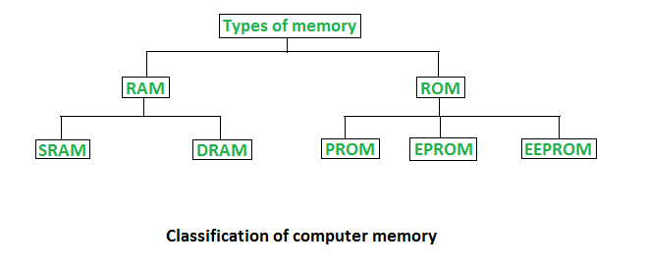. Example, RAM

Random Access Memory (RAM): is an internal processor, where data is temporarily stored while programs are running. Could write to and read from this memory. As its content is lost when computer power is turned off, it is also referred to as a transient or temporary memory. RAM stores the currently in use records, files, or part of the operating system.

## Types of RAM

two main types of RAM

* DRAM (Dynamic Random Access Memory)
* SRAM (Static Random Access Memory)

## Dynamic Random Access Memory

* Constructed of tiny electric leak-leak capacitors.
* Requires a charge to maintain its data every milliseconds.
* Low-cost.
* Less than SRAM
* Multiple bits can be stored per chip.
* Less fuel is used.

## Static Random Access Memory

* Their contents are started until system is on
* Expensive
* Faster than DRAM.
* Cannot store of a lot bit per chip.
* Uses power.
* Gives more heat.
* Used for a cache

Read-Only Memory (ROM): is a memory used to store permanent knowledge. It is also used to contain data for a computer program. For example, on configuration. These chips can not be modified, can only be read (hence their name) from.

## Types of ROM

There are three main ROM types.

* PROM
* EPROM
* EEPROM

## Programmable Read Only Memory (PROM)

PROM is ready for the memory chip that a user can reach only once. The difference is that during the production process, ROM is programmed; PROM is produced as a bank memory. The user buys a PROM; after making it, the user needs a special device called a PROM programmed by “Blowing” the fuses, which is an irreversible process.

## Erasable programmable read only memory (EPROM)

EPROM programming memory which stores it data even if the power is turned off. The data can be retrained once the system is on without any loss.

## Electrically erasable programmable read only memory (EEPROM)

This kind of read only memory is used in microcontrollers, smart cards, etc. it is there to store small amount of relative data.

# 1.2 Analyse networking infrastructures

## Computer network:

A group of computer connected with each other is called computer network. This ranges from basic school/home networks of only a few computers to large networks such as internet, which effectively allows any computers connected to it to communicate with any other computer similarly connected.

Types of computer network

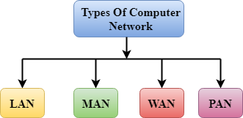Many types of networks appear, including:

## Local area network (LAN):

These systems are usually within one building, or certainly not very far away from each other geographically. A typical LAN will consist of a number of computers and device (for example, printers) that are connected to hubs or switches.

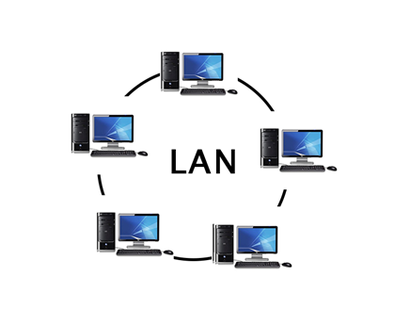

**Metropolitan area network (MAN)**

MAN is a network for a larger area than LAN but smaller than WAN. Basic use of MAN is 3G mobile networks

## Computer Network TypesUses of MAN

* Mobile towers
* Offices
* Schools
* Hospitals
* Airports

## Wide area network (WAN)

WAN are used where computers or networks are situated a long distance from each other geographically. If a number of LANs are joined together using a router or modem, then they can form a WAN. The most common examples of WAN include the internet and the network of ATMs used by banks. Because of the long distances between devices, WNs usually make use of some public communications network. Like, telephones lines or satellite. They have less risk of getting hacked

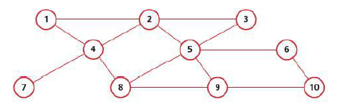

## Examples of wide area network:

* Internet
* International banks
* Private school networks
* Government offices

## Advantages of wide area network

The wide area networks advantages are as follows:

* All computers can access the same services and resources (such as printers, scanner, internet access) from anywhere within range of Aps.
* Safer and flexible.
* Adding new computers and devices are easy
* Low costs

## Disadvantages of wide area network

The following are the wide area networks disadvantages:

* Security can be a big issue since anyone with a WLAN-enabled laptop can access a network if it can pick up a signal; it is therefore necessary to adopt complex data encryption techniques.
* There may be problems of interference, which can affect the signals.
* The data transfer rate is slower than wired LAN

## Personal area network (PAN)

This kind of network is established within a house and used to connect smaller devices. For example, a computer connected to another computer, speaker, printer, phone, headphone, etc.

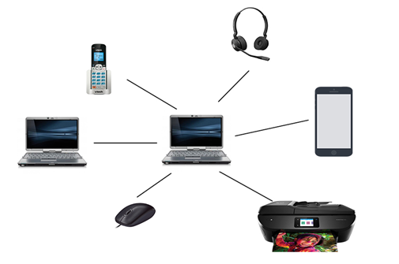

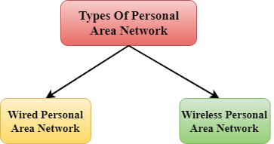

## Wired personal area network

Using a piece of hardware to connect devices with each other.

## Wireless personal area network

Short distant network commonly used in houses and offices to connect normal daily use devices like printers, mouse, phone, fax machine, etc.

Examples of personal area network:

## Body area network:

Network used for small devices, which are on or around your body. For example, smart watches, vital signs, etc.

## Offline network:

Network to create connectivity with a room like an office to connect devices without Wi-Fi i.e. Bluetooth

## Small home office:

Using a virtual private network which connect various devices to internet also a corporate network.

## Network infrastructure:

Network infrastructure is the hardware and software resources of an entire network that allows an enterprise network to connect, operate and manage. It provides users, process, applications services and external networks/the internet with the commutation path and services.

In most enterprise IT environments, network infrastructure is typically, part of the IT infrastructure. It interconnects the entire network infrastructure and can be used for internal communications, external communications or both. A typical infrastructure for the network includes:

## Networking hardware:

* Routers
* Switches
* LAN cards
* Wireless routers
* Cables

## Networking software:

* Network operations and management
* Operating systems
* Firewall
* Network security applications

## Network services:

* T-1 line
* DSL
* Satellite
* Wireless protocols
* IP addressing

## Network devices:

Network devices or networking hardware is physical devices required on a computer network to communicate and interact with hardware.

Types of network devices

Here is the list of popular devices on the network:

## Hub

Hubs are hardware devices that can have a number of devices or computers connected to them. They are often used to connect together a number of devices to form LAN – for example, a star network (see later). Is main task is to take any data packet (this is a group of data being transmitted) received at one of its ports and broadcast it to every computer in the network. This essentially means that using a hub is not a very secure or efficient method of data distribution.

## Switch

Switches are similar to hubs but are much more efficient in the way that they distribute data packes. As with hubs, they connect a number of devices or computers together to form a LAN.

## Router

Routers enable data packets to be routed between the difference networks, for example to join a LAN to a wide area network WAN. A router would typically have an internet cable plugged into it and several cables connecting to computer and other devices on the LAN.

## Bridge

Bridge are devices that connects one LAN to another LAN that uses the same protocol (communication rules). They are often used to connect together different parts of a LAN so that they can function as a single LAN.

## Gateway

Gateways usually work on the OSI models transport and session layers. There are several protocols A gateway is a network point that acts as an entrance to another network. It is a key point for data on its way to or from other networks. All networks will have boundaries so that all communication within the network is conducted using devices such a switches or routers. If a network gateway needs to communicate outside its network, it needs to use a gateway.

## Modem

Modem means ‘modulator demodulator’ and is a device that converts a computer’s signal into an analogue signal for transmission over an existing telephone line. It also does the reverse process, in that it converts analogue signals from a telephone line into digital signals to enable the computer to process the data.

## Repeater

Repeater is a device that amplifies the reachability of a network signals.

## Access point

## A device receives the radio waves via an installed wireless adaptor which allows it to download the information from the data source. This, of course, works in reverse when the device wishes to transmit data over the network.

# 1.3 Assess the function of components within a chosen computer system.

|  |  |
| --- | --- |
| System 1 | System 2 |
| Lenovo G50-80 | Acer predator 15G9-593G |
| Processor intel Core i3 | Processor Intel Core i7 |
| Computer type: laptop | Computer type: laptop |
| 64 bit – operating system | 64 bit operating system |
| X64 – based processor | X64 – based processor |
| Windows 10 home single language | Windows 10 |
| RAM: 4GB | RAM: GDDR5 16GB |
| Intel i3-4005U | Intel Core 17-7700HQ |
| Screen size 15.6 inch | Screen Size: 15.6 inch |
| Hard disk: 2TB | Hard disk: 1Tb+256GB |
| Processor speed: 1.6 GHz | Processor speed: 2.26GHz |
| No touch screen | No touch screen |
| Price: $500 | Price: $1100 |
| 3 battery cells | 4 battery cells |
| RAM size: DDR4 4GB | RAM: GDDR5 16GB |
| No GPU | GPU: VGA 8GB |
| Great for everyday use | Excellent in heavy tasks |

Acer Predator 15G is better as per the scenario than Lenovo G50-80 because Acer has more storage space (1TB+256GB) and the storage type is SSD (solid-state drive) which can help in mass and faster storing, Predator uses a newer processor (intel core I7 with 2.6GHz) which increases workflow and heavy tasks can be done easily and quickly. It has a graphic card (VGA) with the storage space of 8GB which can help in graphic designing any kind of visual representation of customer’s car/ add-ons. Acer also have DDR5 (16GB) which helps in handling large amount of cache data and heavy computing. Acer predator has a quad-core processor which helps in working for long hours without the computer to heat up, which can lead to internal motherboard damage. Overall, in my opinion Acer predator 15G-593G matches the requirements according to the scenario and will help expanding the business and is more networkable as it has many input/output ports.

# 1.4 evaluate peripheral devices to meet different purposes

## Input device:

## As the name suggests, these are hardware devices that allow data to be input into a computer. Many such device exist, ragging from the more common ones, such as the keyboard, through to the more specialist devices, such as barcode readers.

## Examples of input devices:

For any computer system, a keyboard is the most important input unit. It was usually the only input system in early computing days. A keyboard includes letter and number keys as well as complex functions.

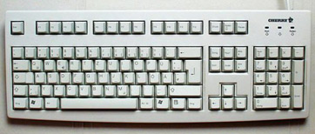

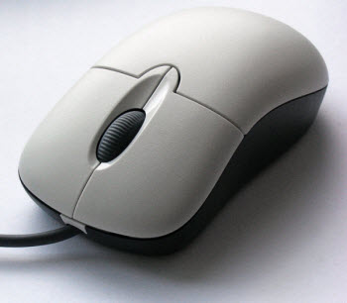The mouse is an example of a pointing device. The user controls the position of a pointer on the screen by moving the mouse around. There are usually two button, which have different function: the left button is usually used to menus.

## Output deceive

These are hardware devices that allow data to be output from a computer. Some devices hold the data temporarily (such as in a printer buffer/memory) whereas others produce permanent output in the form of a hard copy (such as a printer producing output on paper). There is a third type of output device that is used to control processes in conjunction with sensor input devices.Printers: Printers are used to get a hard copy of a document or a picture. A command is given from a computer device and then it goes to a printer by a USB cable.

There are 2 types of printer:

1. 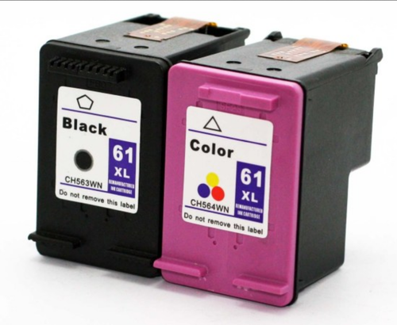Inkjet- uses warm ink, which dries and sticks to the paper. This kind of printers are used in low volume printing and are way cheaper than the other.

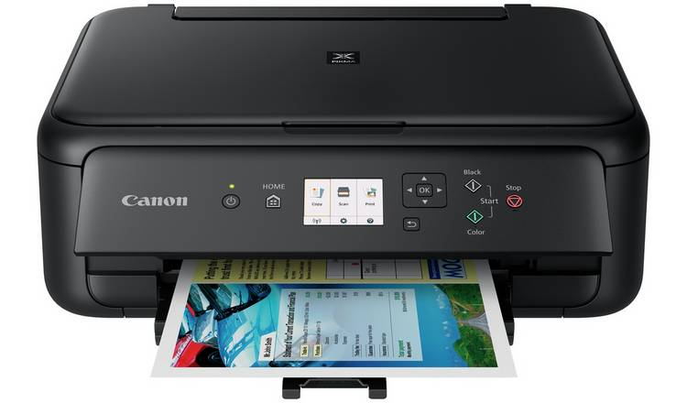

1. 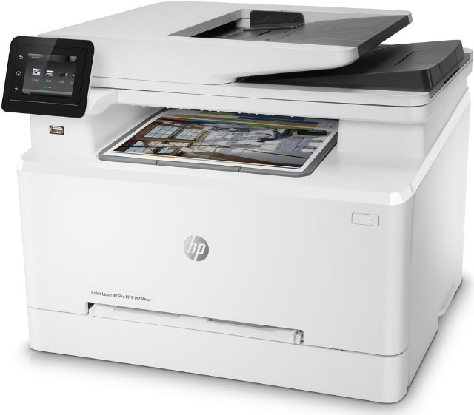LaserJet: Has its cartridge as toner which is in powder form unlike inkjet which has its cartridge containing wet ink. The toner is electronically heated to be printed on. LaserJet printers are usually used in offices, bookstores, making labels, fliers and brochures.

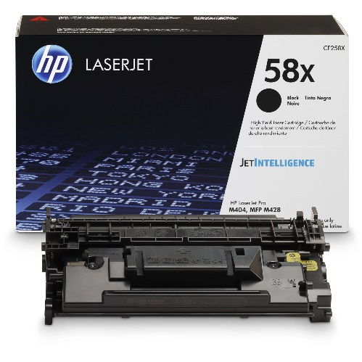

# 2.1 evaluate different operating systems explaining their role in managing resources

## An operating system

The OS is essentially software running in the background of a computer. It manages many of the basic functions.

For applications, an operating system may perform the following services:

* In a multitasking operating system, where multiple programs can run simultaneously, the OS determines which applications should run in which order and how much time should be allowed for each application before turning over to another application.
* It manages internal memory sharing between multiple applications.
* This manages input and output from and to connected hardware devices such as hard disks printers and ports for dial-up.
* It sends messages to each program or remote user (or to a device operator) about the state of service and errors that may have occurred.
* It can unload batch jobs management (e.g. Printing) in order to free the initiating program from this project.
* An operating system can manage how to partition the program so that it runs on more than one processor at a time on computer that can provide parallel processing.

# 2.2 critically assess the use of the different software applications to meet specific purposes

The term “software” refers to the set of instructions for the electronic program or data read by a computer processor to perform a task or operation. The term “hardware” on the other hand, refers to the physical components you can see and touch, such as the hard drive, mouse, and keyboard. Technology can be classified to do what it is intended to do.

There are usually two major software classifications, system software and application software.

## System software

A system software allows the user and the hardware to communicate with each other and connect. Essentially, it is a software to manage the Behaviour of computer hardware to provide the user with basic functionality. Simply put, we can assume that system software is a middle layer between the user and the hardware. For the other software to work in, this computer software authorizes a network or system. That is why system software is very important for the management of the entire computer system once you turn on the computer for the first time, it is the system software that is initialized and loaded into the system memory. In the meantime, the system software is running and is not used by end-users. System software is also known as low-level software.

Examples of common system software are:

* Android
* Macos
* IOS
* Linux
* Ubuntu
* Unix
* Mac OS
* Windows

Operating system: it is system software’s most prominent example. A software collection manages resources and provides general services for other applications running over them. While each operating system is different, most of them provide a graphical user interface that allows a user to access files and folders and perform certain tasks. Each computer, whether it is a desktop, laptop or cell phone, needs an operating system to provide it with the basic functionality. As an operating system ultimately defines how a user communicates with the system, so many users prefer to a use a different operating system for their computer. There are different types of operating system, such as real-time, embedded, distributed, multi-user, single-user, desktop, web etc. when selecting an operating system, it is important to consider the hardware requirements.

## Device drivers

This is a kind of software that regulates different hardware connected to the device. Computer devices that allow a driver to connect to a system include displays, sound cards, printers, mice and hard disk drives. Two types of device drivers are also accessible: kernel device drives and user device driver. Serval system driver examples are:

* BIOS driver
* Motherboard drivers
* Sound card drivers
* USB drivers
* VGA drivers
* Virtual device drivers
* ROM drivers
* Printer drivers

## Firmware

Firmware is the permanent program stored in a memory that is read-only. It is a compilation of permanently stored instructions on a hardware device. This provides important knowledge on how the computer communicates with other hardware. Firmware can be considered as “semi-permanent” as it remains permanent unless it is upgraded with a firmware updater. Few firmware examples are:

* BIOS
* UEFI
* Computer peripherals
* Embedded systems for consumer applications

## Programming language translators

These are mediator programs on which software programs rly to simplify machine-level code by translating high-level languages content. The translator, in addition to simplifying the languages also do the following:

* Assign data storage
* Enlist source code as well as software information
* Provide diagnostic reports
* Correct system errors during runtime
* Interpreter, compiler and assembler are examples of programming language translators.

# 2.3 assess the use of web applications to enhance user experience.

## Web application:

Web application is a remote server used at a large scale like school or offices. A web browser usually accesses web application. It is easier for a developer to make a web application, as the developer does not have to make it for different operating systems. For example, the developer of google chrome have to make two same google chrome servers for window and MAC however, the developers of a single application that runs on chrome will work on both and the developer will have to update the serve and the users of MAC or windows will automatically be updated instead of discretely sending the update to different operating system and their users.

There are six types of the web applications.

* Static web application
* Dynamic web application
* Online store or e-commerce
* Portal web app
* Animated web application

## Static web application

The first thing to know if you chose to create a static web app is that this type of web app shows very little functionality and is not very versatile. Typically, they are built in HTML and CSS. Animated objects like banners, GIFs, videos, etc. can also be included and displayed in them however, with jQuery and Ajax, they can also be created. Therefore, it is not easy to modify the content of static web apps. You must first download the HTML code to do this, then edit it and then upload it to the server again. Only the webmaster or the development company that first planned and designed the app can make these changes. Examples of development of static web apps include professional portfolios or digital curricula. Likewise, this type of web application could also be used by a web page advertising a business to view contact information or similar.

## Dynamic web application

Dynamic web applications at a technical level are much more complex. They use databases to load data and update their contents whenever the user accesses them. We typically have an administration panel (called CMS) that allows administrators to correct or change the content of the app, including text and images. For the development of dynamic web applications, several different programming languages can be used. PHP and ASP are the most frequently used languages because they allow you to organize the content. Upgrading content in this form of app is very easy and you do not even have to access the server when you alter it. This also includes other features such as forums or databases to be implemented in addition to content design can be modified to match the preference of the administrator.

## Online or e-commerce

If the web application is an online store or shop, it is likely that its development will resemble that of m-commerce or e-commerce. The development process of this type of app is more complicated as it must enable electronic payments via credit cards, PayPal or other methods of payment. The development must also create the administrator’s management panel. It will be used to list, update or uninstall new products and manage orders and payments. The el Corte ingles department store is an example of a major Spanish company that has developed a web application for an online store. The web app suits mobile devices in the same way that a mobile app does, allowing it to connect as if it were a native app.

## Portal web app

By portal, we refer to a type application in which, through a home page, we access serval of its sections or categories. Such programs can include several things: forums, conversations, emails apps areas accessible through registration, the latest content, etc.

## Animated web app

Flash technology is necessarily synonymous with an animation. This programming approach enables animated impact material to be viewed. It also makes for more imaginative and futuristic projects and is one of designers and creative directors most commonly used innovations. The internet drawback to developing animated web applications is that this type of technology is not appropriate for web positioning and SEO optimization purpose because search engines are unable to read the information found there in correctly.

# 2.4 assess the use of mobile applications to enhance user experience

## Mobile applications:

Most commonly referred to as an app, a mobile application is a type of application software designed to run on a mobile device, such as a smartphone or tablet computer. Mobile applications also serve to provide similar service for users to those accessed on PCs. Apps are generally small individual units of apps with limited functionality. Apple Inc. and is app store first popularized this use of app software, which provides thousands of apps for the iPhone, iPad and iPod touch. An email, web app, internet app, iPhone app or smart phone app may also be recognized as mobile app. Mobile applications are a move away from built-in software systems commonly found on PCs. Alternatively, each app offers restricted and isolated functionality such as a game, calculator, r mobile web browser. While applications may have avoided multitasking due to the limited hardware resources of the early mobile devices, their specificity is now part of their desirability, as they allow consumers to choose what their devices can do. The easiest mobile apps take applications running on PCs and then move them to a mobile device. This approach is somewhat lacking as the mobile apps become more robust. A more sophisticated approach involves specifically developing for the mobile environment, taking advantage of both its limitations and its advantage.

For example, apps that use location-based functionality are typically designed with eyes to mobile from the ground up, since the consumer does not have the same location concept on a PC.

There are four types of the mobile applications

* Native apps
* Mobile web apps
* Progressive web apps
* Hybrid web apps

## Native apps:

Native mobile devices are specifically designed for a specific type of operating system. They are called native because they are native to a particular device or platform. Apps built on one type operating system. Android apps, in other words, cannot be used on an iPhone. They use the development tools and language by the respective platform (e.g., iOS X-code and Objective-C, Eclipse, and android java). This provides full access to controls of all apps, such as contacts, camera, sensors etc. native applications can be downloaded through e.g. - android apps on google play stores, iOS apps on the app store, etc.

## Example of the native apps:



Using native device operating system APIs and SDKs, mobile native apps ae created. These are programmed using platform-specific languages such as the iOS objective C, android java, and windows phone. One can use the standard GUI components that are part of the SDK stack, quickly creating a native and straightforward. Such applications will be able to access all computer hardware including the different sensors and peripherals if any. These apps are fast since the executable is compiled for the particular OS and directly on the OS. They come with their development environments to do actual system testing, including different simulators and infrastructure.

## Mobile web apps:

These are the desktop frameworks or delivering web pages on mobile devices running web browsers. These are cloud-based mobile apps that are not installed on your mobile handheld device and run on servers hosted on the internet. Mobile web applications usually use web technologies such as HTML, CSS, JavaScript and JQuery. We cannot control all of the functionality of native devices (camera, calendar, geolocation, etc.).

## Examples of mobile web apps:

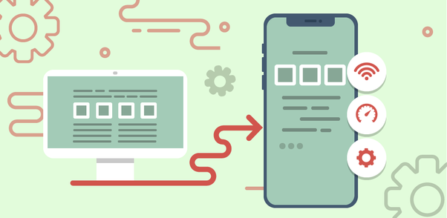

The architecture of mobile web apps:

Mobile web apps are designed to run on your mobile web browser. These are built using multiplatform web technologies such as HTML5, CSS and JavaScript. Thus, it is safe to consider HTML5 as the technology of choice for developing mobile web apps.

## Hybrid apps:

Mixtures of desktop and mobile web applications are hybrid apps. They live in an app store like native apps, and can take advantage of the many devices that are available. Unlike web apps, they rely on HTML being made in a browser, with the exception of embedding in the app. These are built using frameworks such as HTML, CSS, JavaScript, JQuery, mobile, Cordova/ phone gap etc. hybrid applications, including native apps, are also installed in the system, and disturbed through the app store. These are ideal for developing apps that do not have a high-performance requirement but require full access to the device.

## Examples of hybrid apps:



## Progressive web apps:

Progressive web apps are like regular web sites but provide additional user functionality such as offline service, and access to computer hardware that was previously only available to mobile apps from local websites. The great thing about PWAs is that they can be accessed on the smartphone home screen via an app icon and leads to the apps website as soon as you click. PWAs are state of

# Bibliography:

* <https://www.computerhope.com/jargon/m/memory.htm>
* <https://www.computertechreviews.com/definition/ram-random-access-memory>
* <https://www.slideshare.net/geeksagar/primary-memory-ram-rom-and-their-types?qid=c6406a29-bc02-4da8-84bd-fdc61ef58616&v=&b=&from_search=1>
* <https://www.techopedia.com/definition/25597/computer-network>
* <https://www.javatpoint.com/types-of-computer-network>
* <https://www.techopedia.com/definition/16955/network-infrastructure>
* <https://blog.netwrix.com/2019/01/08/network-devices-explained/>
* <https://study.com/academy/lesson/what-is-an-input-device-for-a-computer-definition-examples-quiz.html>
* <https://whatis.techtarget.com/definition/operating-system-OS>
* <https://squareboat.com/blog/different-types-of-software-with-examples>
* <https://techterms.com/definition/web_application>
* <https://en.yeeply.com/blog/6-different-kinds-web-app-development/>
* <https://www.techopedia.com/definition/2953/mobile-application-mobile-app>